Number Talk Reference Lists

Number Talks: Routine Steps
1. Present the problem.
2. Give students time to solve.
3. Allow student volunteers to share answers.
4. Choose a few students who found the correct answer to share their strategy and thinking. Show these student’s strategies and thinking in a visual way.
5. Allow students to discuss the strategies shown and offer supporting comments or ask questions.

Number Talk Responses
- I like your thinking!
- Can you tell me more about your thinking?
- Thank you for sharing your thoughts.
- Great job using one of our strategies.
- What did you do next?
- Was that the only strategy that helped you solve the problem?
- How did you find that answer?
- Thank you for sharing!
- Can you give me another example?
- You’re on the right track!
- That makes sense to me too.
- I like how hard you are trying.
- I like how you said “____”. Good job with that!
Number Talk Expectations and Reminders
Anchor Chart Example (Expandable Example Picture Included)

NUMBER TALKS: Expectations and Reminders

When we do Number Talks, we:
- Listen and/or read the problem carefully.
- We do our best thinking silently and independently.
- Show a secret, silent thumbs up on our chest when we have one strategy to share. Or, show a 2, 3, 4, or 5 fingers if we have more than one strategy to share. (Remember to keep it a SECRET thumbs up so that no one feels rushed and everyone has enough time to think.)
- Listen respectfully to other’s explanations.
- Show a double thumbs up to show that we agree with someone else’s thinking.
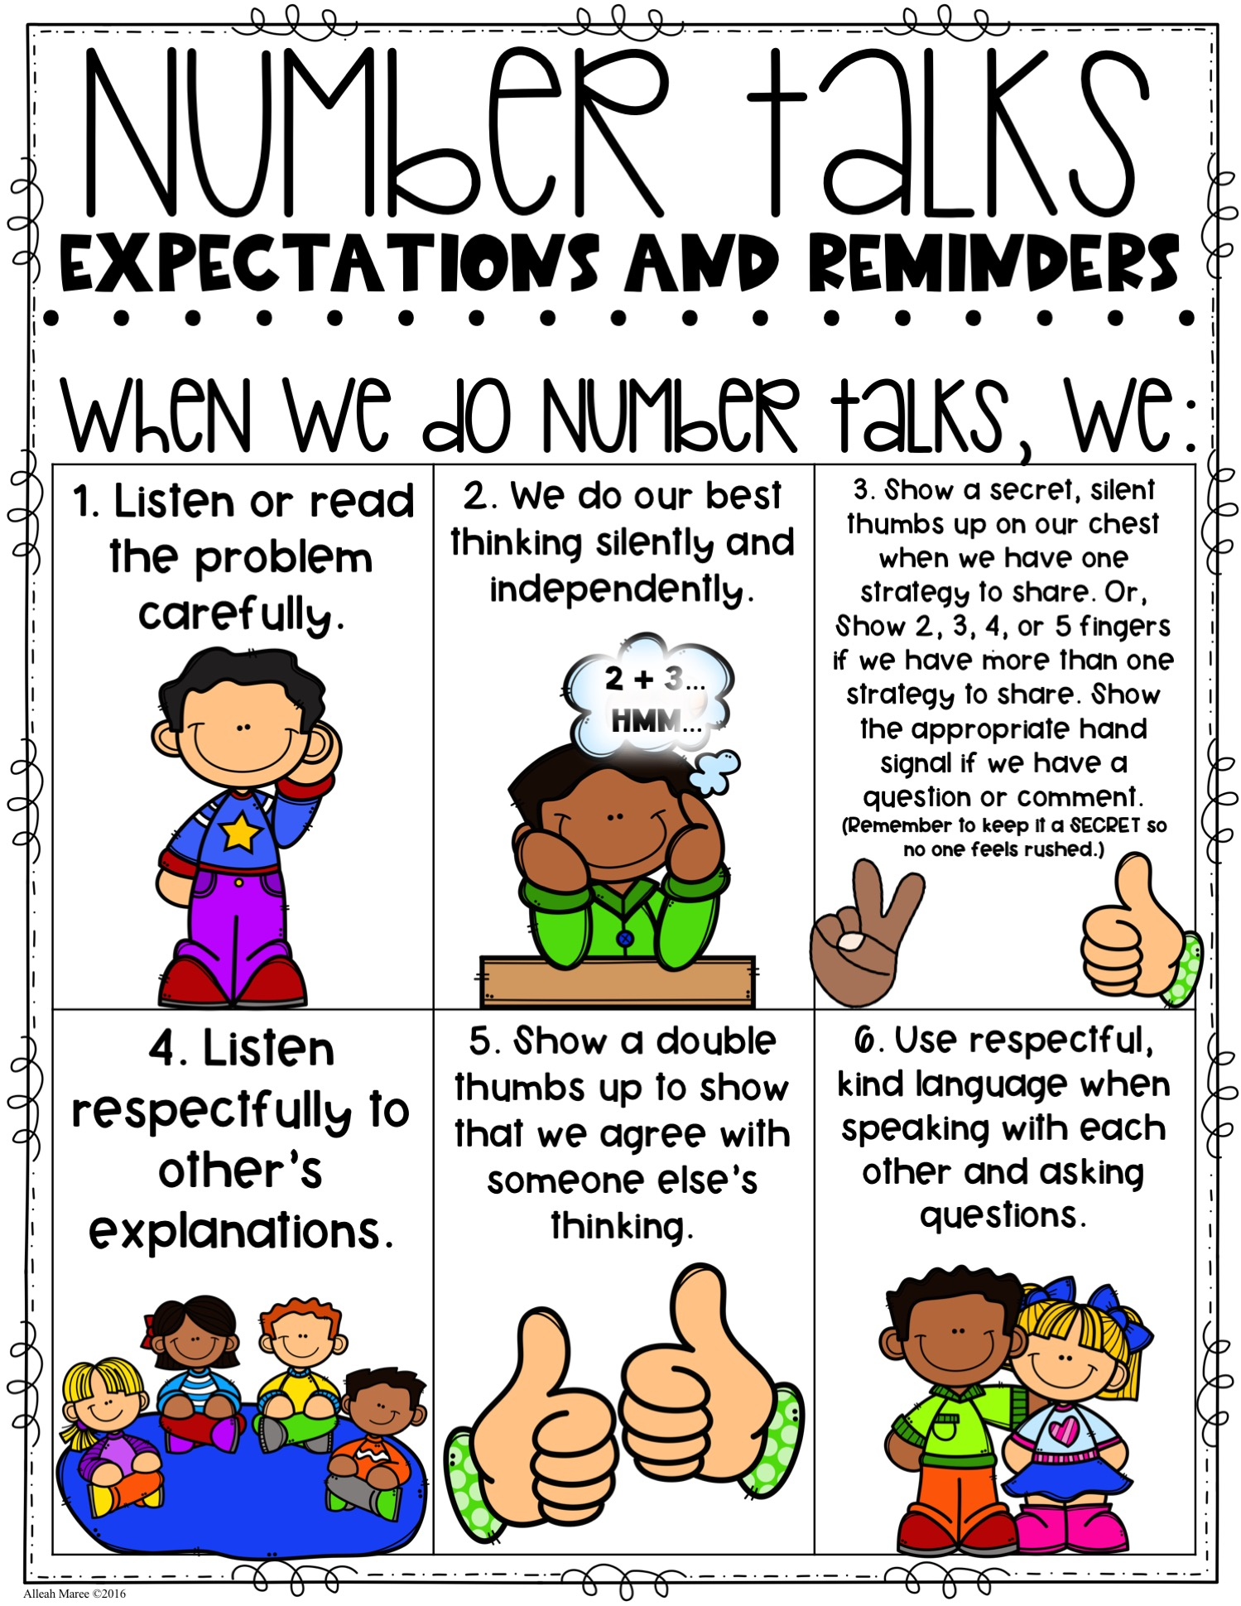
- Use respectful, kind language when speaking with each other and asking questions.
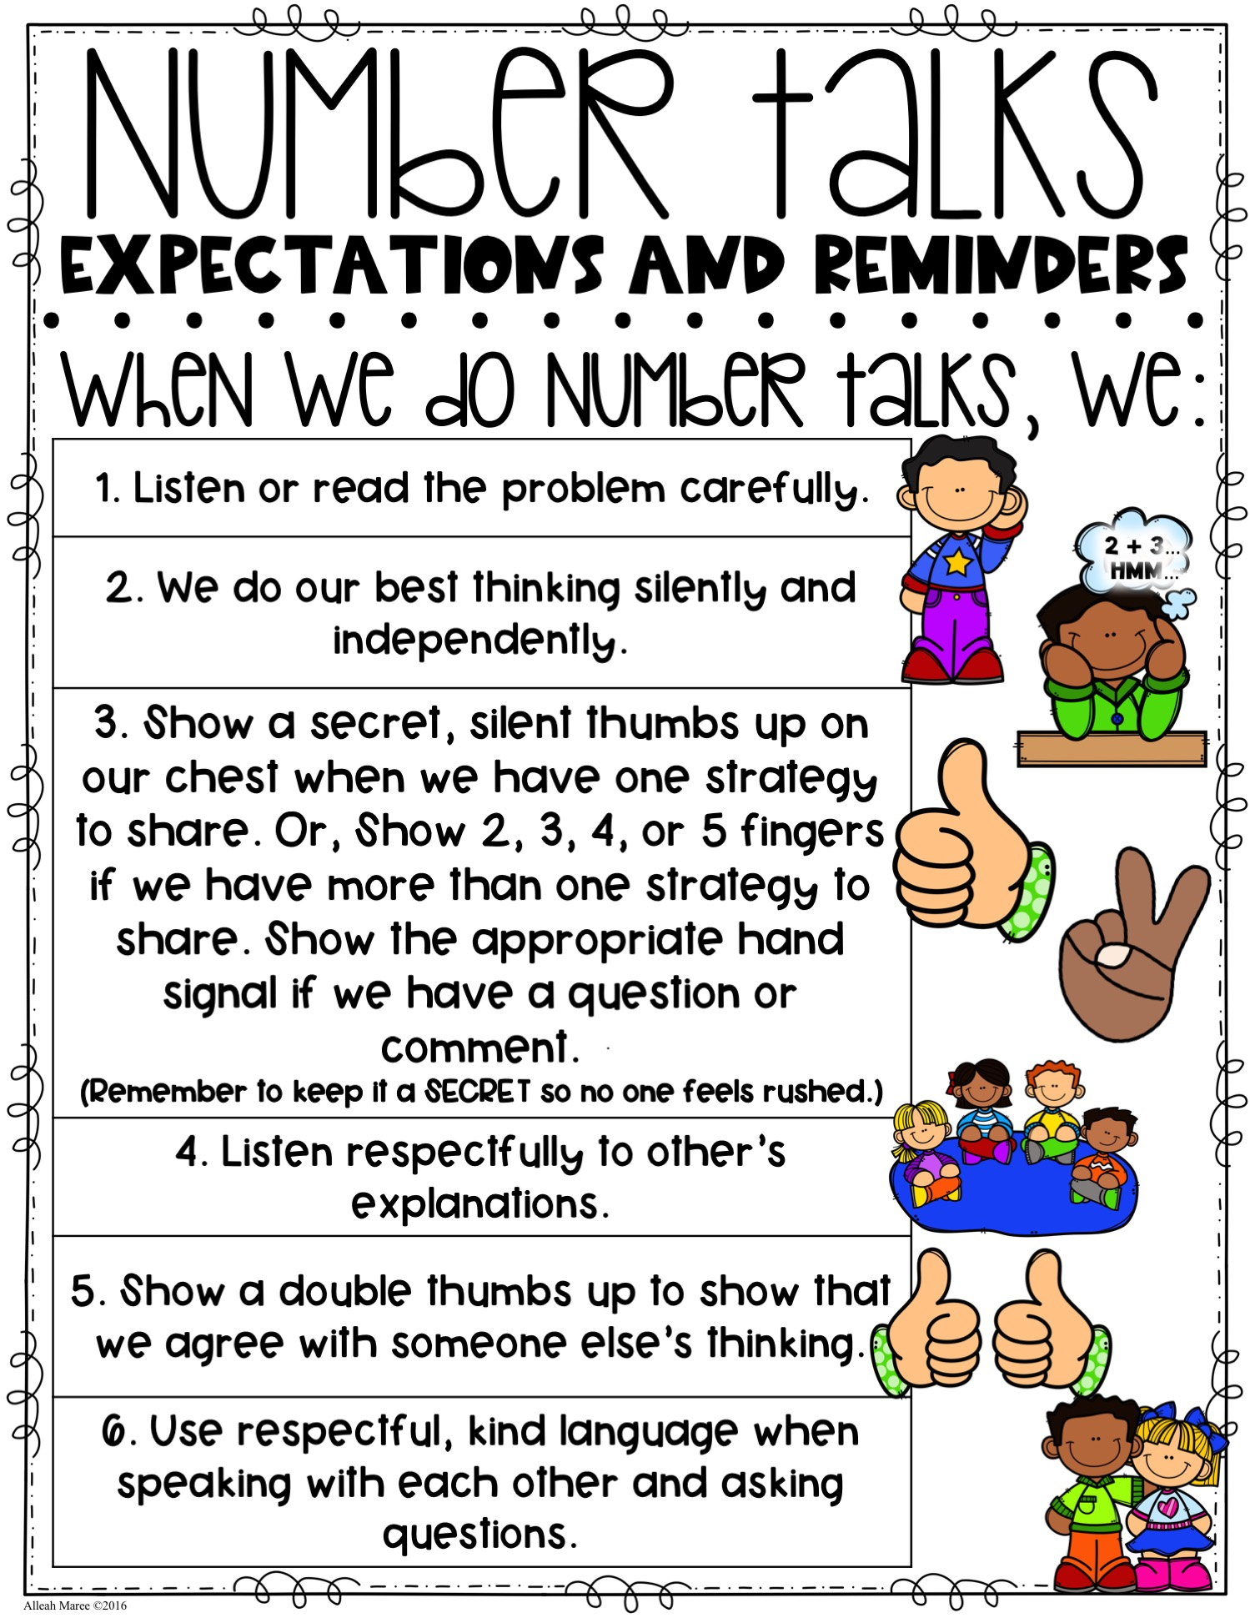

Number Talk Expectations and Reminders Anchor Chart Template
1. Give instructions for how students will understand the problem. ______________________________________________________________
______________________________________________________________
2. Remind students of behavior expectations during think time.
______________________________________________________________
______________________________________________________________
3. Instruct students how to show that they’re finished thinking and ready to share.
______________________________________________________________
______________________________________________________________
4. What are students expected to do while others are sharing.
______________________________________________________________
______________________________________________________________

5. Describe how students will show their agreement or questions during discussion.
______________________________________________________________
______________________________________________________________

6. Describe what is expected concerning students’ communication during Number Talks.
______________________________________________________________
______________________________________________________________

